**Client-Side App Rubric** <https://github.com/denisecase/pbl-lifeline-links>

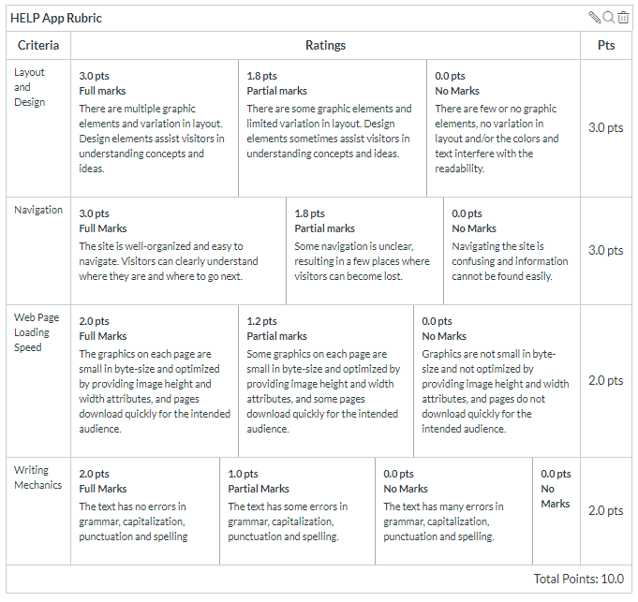

**Team reviewed: group01-04**

**Link to the web site:** <https://dakotagrvtt.github.io/pbl-lifeline/>

**Layout and Design**

Score: 1

Comments: Overall the layout is simple and kept on one page, which may or may not work depending on what is wanted. However there is a lack of a logo on the header, making initial visitors potentially confused about what site they’re visiting. When you load up the page initially, there is no determining factor telling you about what site you are on and that’s a big issue with the targeted market.

**Navigation**

Score:3

Comments: The navigation works fine, it all loads the same page as opposed to some going to one site and others going to another. This works well with the flow of the site, working its way down the page as the nav works across.

**Loading Speed:**

Score:1.75

Comments: The overall loading speed seemed a bit slower compared to other sites due to the image that takes up most of the screen as you load and the issue with that is that having such a big image slowing down the load times above the fold (what you see as soon as the site loads) may lead users away because it’s not instant like what is expected in today’s age.

**Writing Mechanics:**

Score: 2

Comments: There were no visually noticeable grammar errors.

**General remarks:**

The site still needs work as it is missing a logo on the top to identify what site users are actually visiting. That will be a major issue due to the users not knowing whether or not the site is the site they want. The product is marketed towards older people (as seen by the initial image) and not having any identifier will cause for them to potentially feel like the site isn’t the one they’re looking for.

**Review performed by:**

**Ricky Calderon**

**Aaron Stahl**

**Date and time performed:**

**12/5/2019 1:00**